Woolridge Chapter 6   
 Question C6.9 (NBASAL data)

C6.9

t-statistic for each explanatory variable is calculated for following Null and alternate hypothesis

H0: Coefficient of an explanatory variable is 0

H1: Coefficient of an explanatory variable is not 0

Ans i) Estimated equation by applying ordinary least squares:

*points* = 35.22 + 2.364\**exper* -1.704\**age* -1.286\**coll* -0.077\**expersq*

Standard error, t statistic is given in below table

|  |  |  |  |  |
| --- | --- | --- | --- | --- |
| term | estimate | std.error | t-statistic | p.value |
| (Intercept) | 35.21831 | 6.986731 | 5.040742 | 8.62E-07 |
| exper | 2.363631 | 0.405497 | 5.828965 | 1.62E-08 |
| age | -1.07396 | 0.295072 | -3.63965 | 0.000328 |
| coll | -1.28625 | 0.450592 | -2.85459 | 0.004651 |
| expersq | -0.07703 | 0.023483 | -3.28008 | 0.001177 |
|  |  |  |  |  |

n = 269, R-squared: 0.1412, Adjusted R-squared: 0.1282

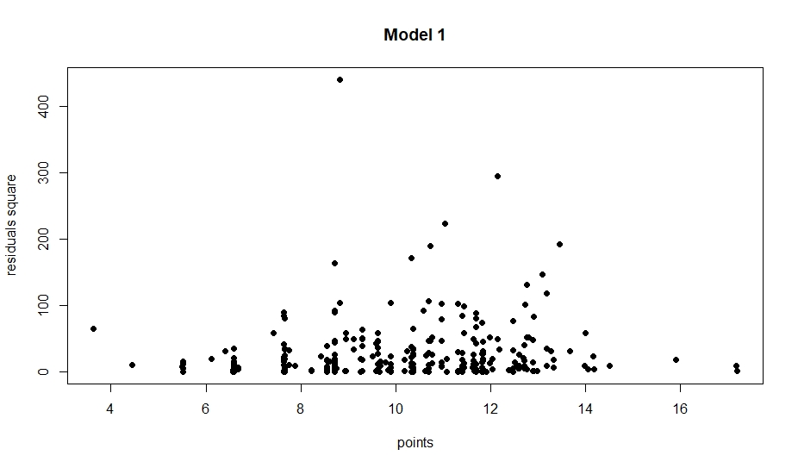

Checking homoskedasticity. p-value =0.6029>0.1(level of significance)

Can’t reject Null hypothesis that residual is homoskedastic

Ans ii) We can get it by just differentiating estimated equation with respect to exper. After differentiating we get:

$\frac{d(points)}{d(exper)}$ = 2.364 – 0.1544*exper

It takes value zero at exper = $\frac{2.364}{0.1544}$ = 15.31

So, if experience increases from 15 to 16 years, if we keep age and coll fixed points actually is predicted to get reduced. This actually doesn’t make sense, but it looks like 15 years of experience is quite high and looking at data we find that out of 269 players only 2 players have experience greater than 15 years.

Ans iii) I think that most of the good players get identified early and leave school/college. These are the players who are supremely talented and hence get paid highly. Getting higher education itself doesn’t affect points directly, but less education indicates that the given person was supremely talented, hence more points for less coll value.

Ans iv) Estimated equation by applying ordinary least squares:

*points* = 73.59 + 2.863\**exper* – 3.984\**age* -1.313\**coll* -0.128\**expersq* + 0.054\**agesq*

Standard error, t-statistic is given in table on next page

n= 269, R-squared:0.1451 ,Adjusted R-squared: 0.1288

|  |  |  |  |  |
| --- | --- | --- | --- | --- |
| term | estimate | std.error | t-statistic | p.value |
| (Intercept) | 73.59034 | 35.93341 | 2.047964 | 0.041557 |
| exper | 2.863828 | 0.612724 | 4.673927 | 4.72E-06 |
| age | -3.98369 | 2.689078 | -1.48143 | 0.139688 |
| coll | -1.3126 | 0.451084 | -2.90989 | 0.003925 |
| expersq | -0.12807 | 0.052438 | -2.44236 | 0.01525 |
| agesq | 0.053551 | 0.049192 | 1.088626 | 0.277315 |
|  |  |  |  |  |
|  |  |  |  |  |
|  |  |  |  |  |

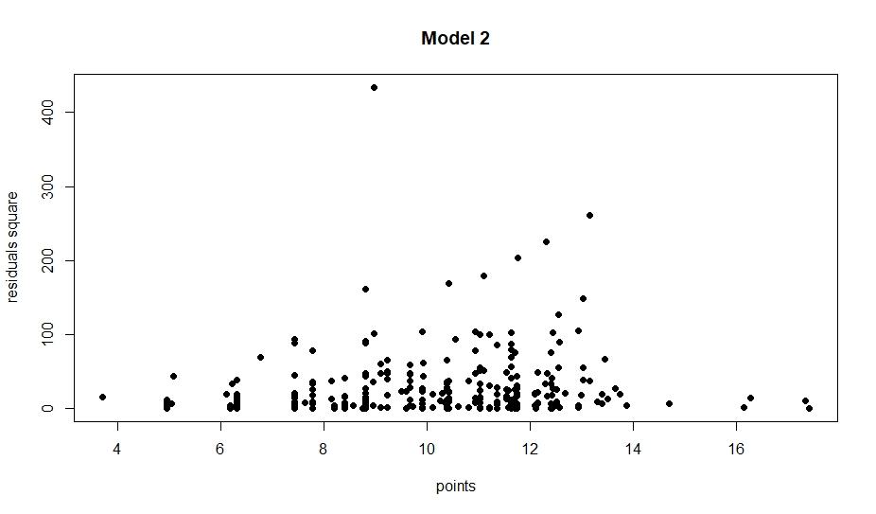

Checking homoskedasticity. p-value = 0.5992>0.1(level of significance)

Hence can’t reject the Null hypothesis that residual is homoskedastic.

From the table, we can see that t-statistic for age squared variable is close to 1. Its p-value is 0.277, it means that we can’t reject the null hypothesis that coefficient of agesq is 0 at a normal level of significance like 0.05 or 0.1. Hence it is not required.

As we are not considering the coefficient of agesq, hence if we fix exper and coll then age has a negative impact on points per games. However if we consider agesq then also same holds for most of the time, points increase with age only when age > 3.984/(2*0.05355) = 37.19 years, from 38 years onwards starts increasing.

Ans v) Estimated equation by applying ordinary least squares:

log(*wage*) = 6.78 + 0.078\**points* + 0.218\**exper* – 0.0071\**expersq* – 0.048\**age* – 0.040\**coll*

Standard error, t-statistic is given in following table

|  |  |  |  |  |
| --- | --- | --- | --- | --- |
| term | estimate | std.error | t-statistic | p.value |
| (Intercept) | 6.779039 | 0.845421 | 8.018536 | 3.53E-14 |
| points | 0.07773 | 0.007113 | 10.92808 | 3.63E-23 |
| exper | 0.217845 | 0.049788 | 4.375471 | 1.75E-05 |
| expersq | -0.00708 | 0.002769 | -2.55792 | 0.011091 |
| age | -0.04814 | 0.034947 | -1.37746 | 0.169542 |
| coll | -0.04027 | 0.052872 | -0.76166 | 0.446945 |

n = 269, R-squared:0.4878 , Adjusted R-squared: 0.4781

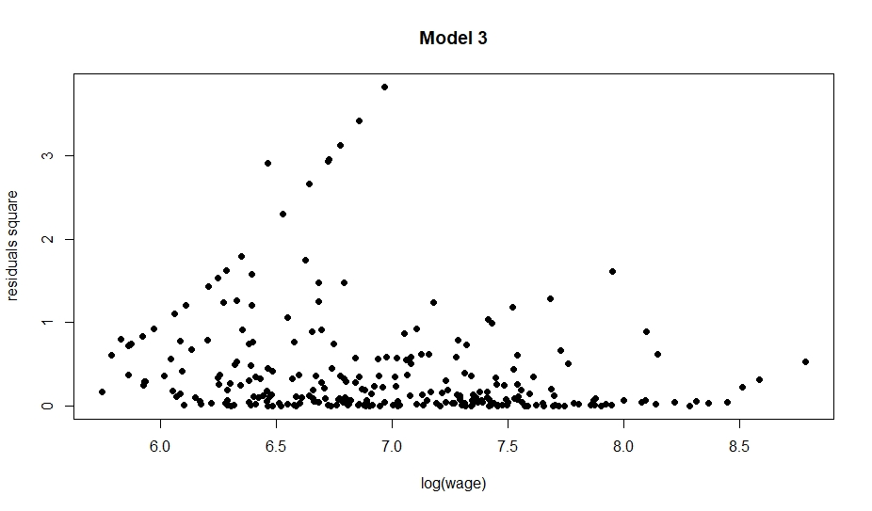

Checking homoskedasticity. Looks doubtful. p-value = 0.0048<0.1(level of significance)

Reject Null hypothesis that residuals are homoscedastic

Estimated equation after running robust regression:

log(*wage*) = 6.47 + 0.072\**points* + 0.20\**exper* – 0.0073\**expersq* – 0.029\**age* – 0.05\**coll*

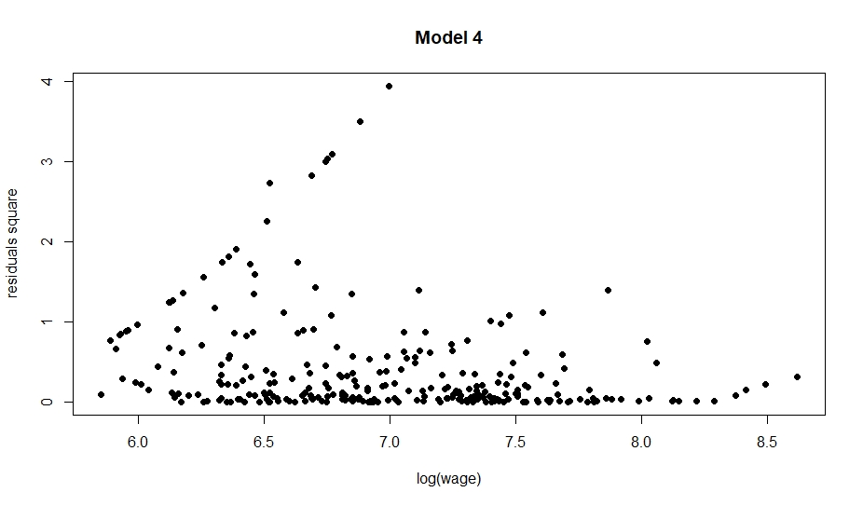

*This model also fails the BPG test(gives same p-value as older model), hence we lower the significance level and work with previous model only.*

We can see that independently we cant reject the null hypothesis that age and coll are 0 at the level of significance like 0.05 or 0.1.

Ans vi) H0 : Coefficient of age and coll are both zero

H1: Coefficient of age and coll are both not zero

By running a joint hypothesis test the F value we get is 1.1891, pr(>F) is 0.3061. So, we can’t reject the Null hypothesis that coefficient of age and coll are both zero. Hence once points and exper are same there is no indication from data that age or years played in college affects wages.